 |  | Week 1
 | Breakfast | Lunch | 1pm Snack | Tea | 5pm snack
Monday | Selection of whole meal & white Buttered Toast & Milk  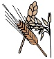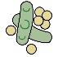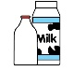  Satsuma | Sweet potato falafel couscous mixed vegetables & tomato sauce  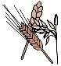  Creamy Semolina with Pureed Apricots  (no added Sugar)  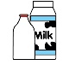 | Breadsticks  +  Fresh Milk | Tuna and sweetcorn pizza with Cucumber sticks  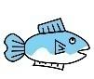  Banana  &  Kiwi | Plums
Tuesday | Malted Wheaties  & fresh Milk  Sultanas & Raisins | Cheese, leek and mushroom pie served with jacket wedges and baked beans.  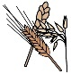  Raspberry sponge & Creamy custard  (no added Sugar)  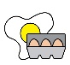 | Rice Cakes  &  Fresh Milk | Bean & vegetable couscous with a garlic sauce  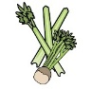  Spiced Apple & oat biscuit  (No added Sugar) | Sliced red Peppers
Wednesday | Cornflakes  with fresh milk  Rasins & Sultana’s | Vegetable & lentil ragu with spaghetti & garlic bread  Mandarin Cheesecake | Oatcakes  &  Fresh Milk | Toasted bagels, sliced eggs & cherry tomatoes  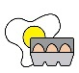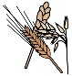  Apples & Melon | Cucumber sticks
Thursday | Selection of whole meal & white Buttered Toast & Milk  Banana | Quorn roast served with Yorkshire puddings, mashed potatoes, peas, and cauliflower gravy  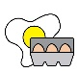  Greek yoghurt with mango pureed  (No added sugar) | Breadsticks  &  Fresh milk | Wholemeal pasta in a tomato and aubergine, courgette and lentil sauce  Cheese Chunks & grapes | Carrot stick
Friday | Selection of whole meal & white Buttered Toast & fresh Milk  Orange | Sweet Potato, courgette & lentil curry with rice  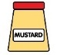  Peaches & creamy custard  (No added sugar) | Oatcakes  &  Fresh Milk |  | Pears

 |  | Week 2
 | Breakfast | Lunch | 1pm Snack | Tea | 5pm snack
Monday | Selection of whole meal & white Buttered Toast & Milk  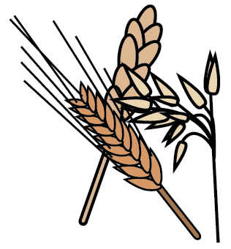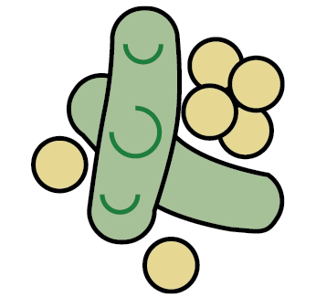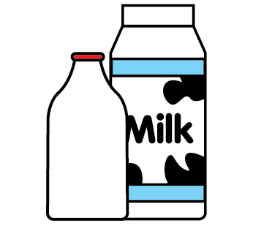  Banana | Vegetable & lentil Balti with boiled rice & naan bread  Pear & mango crumble with ½ fat crème fraiche  (No added sugar) | Rice cakes  &  Fresh milk | Vegetable couscous with rustic tomato & bean sauce  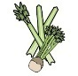  Pineapple  &  Blueberries | Apple
Tuesday | Wheat bisks  Fresh & Milk  Sultanes & Raisins | Quorn shepherd's pie served with cabbage, spinach, and onion gravy  Strawberries & Greek yoghurt  (No added sugar) | Oatcakes  &  Fresh Milk | Wholemeal pasta with parsnips and lentil sauce  Banana & Date slice  (No added Sugar)  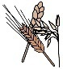 | Carrot sticks
Wednesday | Selection of whole meal & white Buttered Toast & Milk  Kiwi | Tuna & Cheese pasta bake with mixed vegetables  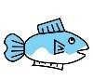  Creamy ground rice with apricot -puree  (No added Sugar) | Breadsticks  &  Fresh Milk | Quorn ham and tomato pizza served with cucumber sticks.  Oaty apple cookie | Satsumas
Thursday | Rice snaps  &  fresh milk  Raisins & Sultanas | Vegetable & bean lasagne with sweetcorn  Chocolate Raisins Sponge &  creamy Custard  (No added Sugar) | Ricecakes  &  Fresh Milk | Salmon & Leek balls with sweet, potatoes wedges  Pears & Oranges | Cherry Tomatoes
Friday | Selection of whole meal & white Toast with fresh Milk  Plums | Ocean pie with green beans & broccoli  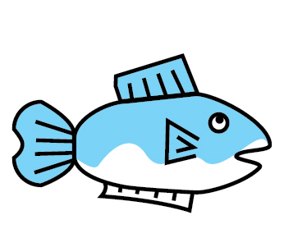  Mandarins & Ice cream | Breadsticks  &  Fresh Milk | Toasted muffins with sliced eggs & cucumber sticks    Grapes & Apples | Pears

 |  | Week 3
 | Breakfast | Lunch | 1pm Snack | Tea | 5pm snack
Monday | Bran flakes  &fresh milk  Sultana’s & Raisins | Quorn lasagne with mixed vegetables & garlic bread  Sticky toffee sponges creamy custard  (no added sugar) | Oatcakes  &  Fresh milk | Assorted sandwiches; Cheese spread, and egg mayonnaise & carrot sticks  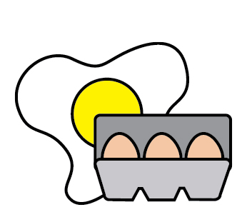  Melon & Blueberries | Sliced peppers
Tuesday | Selection of whole meal & white Toast with fresh Milk  Plums | Fish & Chips with mushy peas  Creamy vanilla rice pudding with Raisins  (No added Sugar) | Breadsticks  &  Fresh Milk | Vegetable dahl with nan bread  Pears & Strawberries | Cucumber sticks
Wednesday | Selection of whole meal & white Toast with fresh Milk  Red Grapes | Vegetable and bean Mexican chilli served with boiled rice and pitta bread.  Tinned Peaches & Greek Yoghurt  (No added sugar) | Rice cakes  &  Fresh Milk  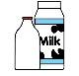 | Tuna pasta with cherry tomatoes and cucumber  Beetroot & chocolate brownie  (No added sugar)  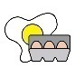 | Bananas
Thursday | Selection of whole meal & white Toast with fresh Milk  Oranges | Cauliflower and broccoli cheesy pasta bake with chickpea ratatouille  Ice cream in a cone | Oat Cakes  Fresh Milk | Fish fingers served with sweet potato wedges.  Blueberries & Pineapple | Apples
Friday | Rice snaps fresh &  Milk  Rasins & Sultanas | Salmon & Broccoli fish cakes with new potatoes, peas & parsley sauce  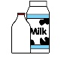  Summer fruit salad | Breadsticks  &  Fresh Milk | Beans on toast with sliced peppers  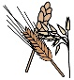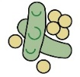  Carrot Cake  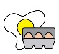 | Plums

 |  | Week 4
 | Breakfast | Lunch | 1pm Snack | Tea | 5pm snack
Monday | Rice Snaps  Fresh & milk  Rasins & Sultanas | Mixed fish Pie with green cabbage & spinach  Banana & Blueberries with Greek yoghurt  (No added Sugar) | Rice cakes  &  Fresh milk | Wholemeal Pasta served in a tomato carrot and lentil sauce  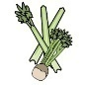  Lemon & raspberry slice | Oranges
Tuesday | Selection of whole meal & white Toast with fresh Milk  Pears | Vegetable and lentil curry with boiled rice  Mixed fruit crumble  With ½ fat cream fraiche  (No Added sugar) | Breadsticks  &  Fresh milk | Fish finger sandwiches served with cucumber sticks.  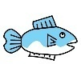  Oaty blueberry pancakes  (No added Sugar) | Satsumas
Wednesday | Selection of whole meal & white Toast with fresh Milk  Satsumas | Chickpea & vegetable farfalle pasta bake with green beans, broccoli & spinach  Fruit jelly  & creamy custard  (No added Sugar) | Oatcakes  &  Fresh milk | Sweet potato and potato wedges served with tuna & Spring onion dip  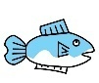  Assorted Grapes | Cucumber sticks
Thursday | Bran flakes &  Fresh Milk  Raisins & Sultana’s | Tuna & cheese fishcakes with salute potatoes sweetcorn & peas with parsley sauce  Ground rice with mixed berry puree  (No added Sugar) | Rice cakes  &  Fresh milk | Black bean and vegetable couscous served with garlic and tomato sauce  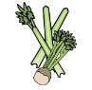  Apple date & oat slice  (No added Sugar) | Pears
Friday | Selection of whole meal & white Toast with fresh Milk  Banana’s | Meatless meatballs in a tomato sauce served with spaghetti.  Apple Pie  and creamy custard  (No added Sugar) | Breadsticks  &  Fresh Milk | Cheese and mushroom pizza  Strawberries & kiwi | Carrot sticks

